

TEXTBOOK
< Unit Test using JUnit in Eclipse >

Code | AAv-QT/NS/HDCV/FSOFT
Issue/revision | 1/0
Effective date | 13/09/2010

TABLE OF CONTENTS
1 Introduction 3
1.1 Purpose 3
1.2 Recommended Users 3
1.3 Definitions, Acronyms, and Abbreviations 3
1.4 Overview 3
2 OVERALL DESCRIPTION 3
3 SPECIFIC TRAINING 3
3.1 TeSt CODE COVERAGE 3
3.1.1 Java code coverage reports in Eclipse 3
3.1.2 Execute test 4
3.2 Excution Unit TeSt 6
3.2.1 Introduction 6
3.2.2 JUnit with Eclipse 7
3.2.3 JUnit (more) in Detail 13

Introduction

Purpose
This document provides a unit test structure overview of the MOCK project, using some technical & tools to execute unit test in the system.

Recommended Users
Fresher pass technical training

Definitions, Acronyms, and Abbreviations
N/A

Overview
This document helps the beginner specially looking for a generic approach. There are also some methods which are described bellow, and making it dynamically which is really handy for maintenance in case of frequent source code change. It includes following two parts :
- Test code coverage
- Execute unit test

OVERALL DESCRIPTION
<This subsection describes the overall description of the training course>

SPECIFIC TRAINING

TeSt CODE COVERAGE
This part describes the Code coverage in Eclipse using EclEmma software.

Java code coverage reports in Eclipse
A part of our team’s “definition of done” is having unit-tests in place and, unofficially, a minimum of 80% code coverage. A Java code coverage plug-in for Eclipse : EclEmma. As you can see from its name, it’s based on the EMMA Java code coverage tool. Here’s a list with its main features :
- a coverage mode in which applications launched or unit tests are instrumented and measured
- coverage overview : a coverage view containing a report on the source code coverage values at project-level, package-level and class-level
- source highlighting in the Java code editor using customizable colors
- customizable coverage counters
- multiple coverage sessions and session merging
- importing EMMA coverage data files
- exporting to EMMA coverage data, XML and HTML
The easiest way to install it is through the update site : http://update.eclemma.org. After the installation, you will notice a new launch mode appearing in the Eclipse toolbar, called Coverage, similar to the Run and Debug modes. This new mode allows you to run coverage reports on applications or unit-tests just like you would before run those applications or unit-tests.
In a project I’m currently working on, our server-side unit tests are written using TestNG. From Eclipse, I can run one or multiple TestNG units using the Eclipse TestNG plug-in, so I can easily verify that my code passes the unit tests. I have defined a launch configuration for each server-side project which runs all of the unit-tests. To check out the code coverage for those tests, all I have to do is create a coverage configuration and make sure that I select the source code folders to be instrumented.

Execute test
Created a sample Java-Maven-TestNG project and added to it a simple class called ShoppingCartImpl along with a TestNG test class. Here’s how it looks :
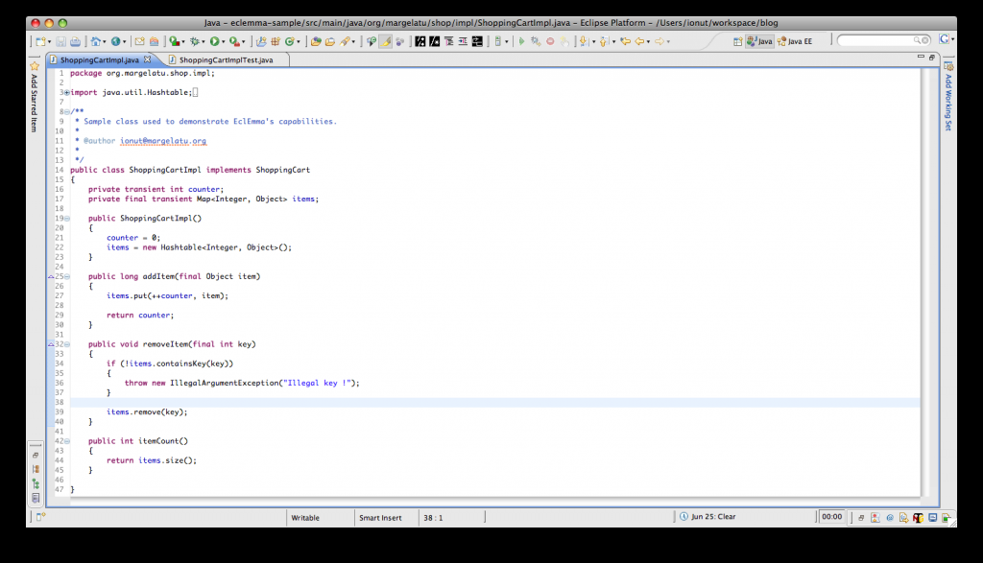
As you can see, this is a very basic class. Now on to configuring the coverage settings ; this is a simple matter of clicking on the Coverage button in Eclipse’s toolbar and selecting the menu option Coverage Configurations…. This opens up the coverage configuration window, as seen below :
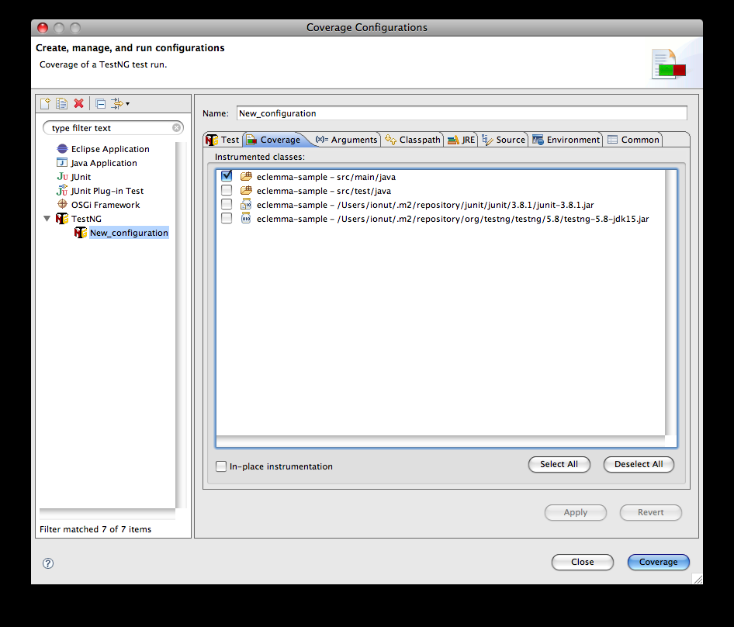
Select the TestNG test suite that you want to run and check the source folders that are relevant to code coverage. Using Maven and all source code is in src/main/java so you only select that folder. Click Apply and then you can finally run the coverage report. Click on the Coverage button and theTestNG configuration is executed and the coverage report is available :
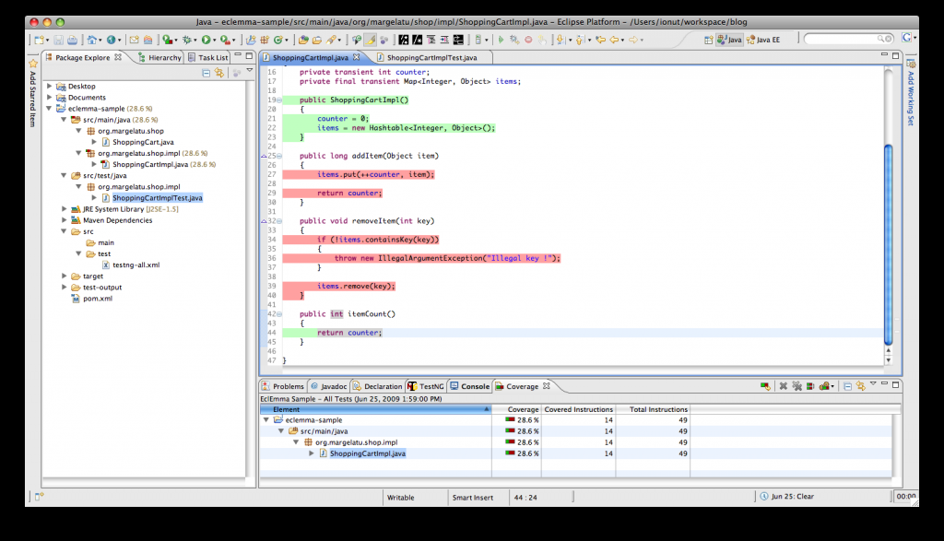
In the bottom of the Eclipse window, you get a clear picture of the code coverage. As you can see, the are reports at project, package and class level, which also show up in the package explorer, in the left. To enable the decorators in the package explorer, go to the Eclipse menu and select Preferences -> General -> Appearance -> Label decorations, then make sure that the Java Code Coverage label decoration option is checked.
Another interesting feature of EclEmma is that after the code coverage instrumentation you can actually see the coverage in the source code. As you can see, each line relevant to the coverage report is marked with a color. Green is for 100% branch coverage, yellow is for some branch coverage and red for no coverage at all. The shopping cart has quite a low code coverage so you did shape it up. After a bit of fiddling with the code, you get a 100% code coverage and a very nice report :
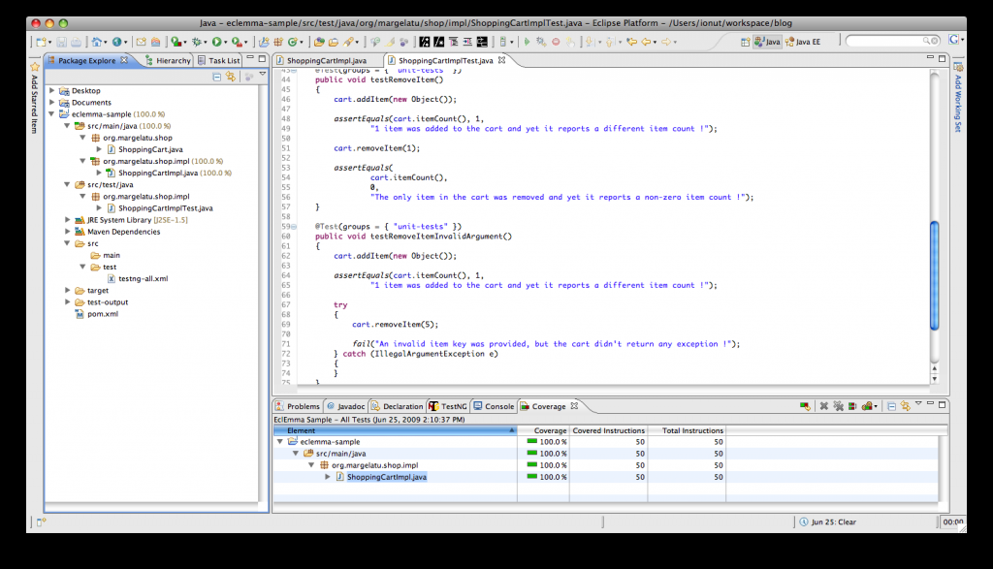

Excution Unit TeSt
This part describes the execution unit test in Eclipse using JUnit.

Introduction

Unit Testing
A unit test is a piece of code written by a developer that tests a specific functionality in the code which is tested. Unit tests can ensure that functionality is working and can be used to validate that this functionality still works after code changes.
Unit testing uses also mocking of objects. To learn more about mock frameworks please see EasyMock Tutorial

Unit Testing with JUnit
JUnit 4.x is a test framework which uses annotation to identify the test methods. JUnit assumes is that the all test can be performed in an arbitrary order. Therefore tests should not depend other tests.
To write a test with JUnit
- Annotate a method with @org.JUnit.Test
- Use a method provides by JUnit to check the expected result of the code execution versus the actual result

Installation of JUnit
Eclipse has JUnit already included, therefore if you intend to use JUnit within Eclipse you don't have to download anything.
Download JUnit4.x.jar from the JUnit website . The download contains a "junit-4.*.jar" which is the JUnit library.
To make JUnit available in your Java project you have to add the the JUnit library file to your Java classpath. See Eclipse IDE Tutorial to learn how to do this in Eclipse

JUnit with Eclipse

Preparation
Create a new project "Sample.junit.first". We want to create the unit tests in a separate folder. Create therefore a new source folder "test" via right mouse click on your project, select properties and choose the "Java Build Path". Select the tab source code.
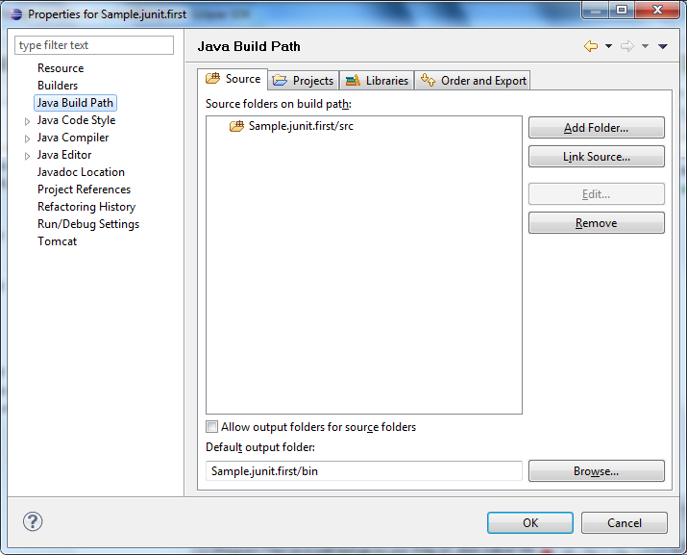
Press "Add folder" then then press "Create new folder". Create the folder "test".
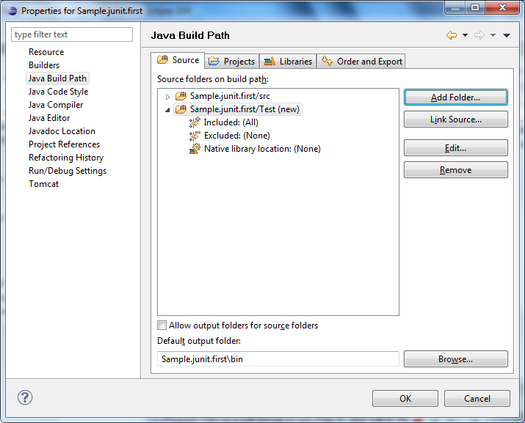

Create a Java class
Create a package "Sample.junit.first" and the following class.
package Sample.junit.first;
public class MyClass {
public int multiply(int x, int y) {
return x / y;
}
}

Create a JUnit test
Select your new class, right mouse click and select New ->JUnit Test case, change the source folder to JUnit. Select "New JUnit 4 test". Make sure you change the source folder to test.
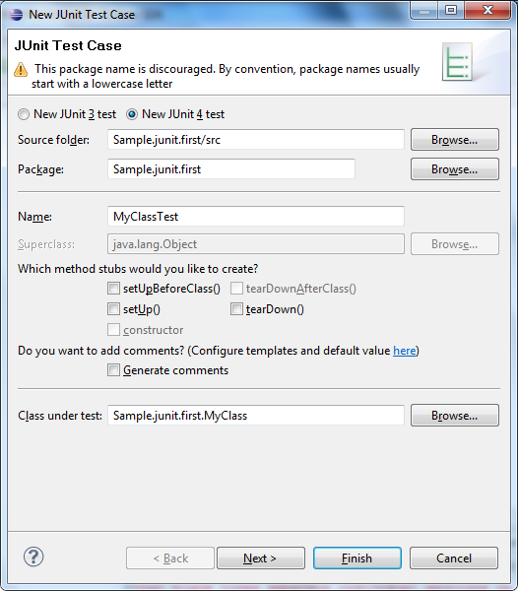

Press next and select the methods which you want to test.
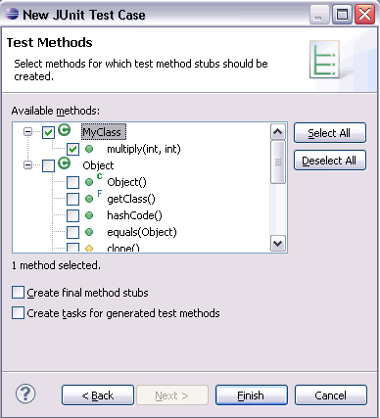
If you have not yet JUnit in your classpath, Eclipse will asked you if it should be added to the class path.
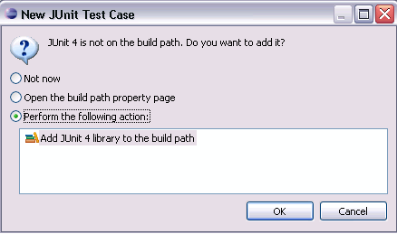
Create a test with the following code.

package Sample.junit.first;
import org.junit.Test;

import static org.junit.Assert.assertEquals;

public class MyClassTest {

@Test
public void testMultiply() {
MyClass tester = new MyClass();
assertEquals("Result", 50, tester.multiply(10, 5));
}

}

Right click on your new test class and select Run-As-> Junit Test.
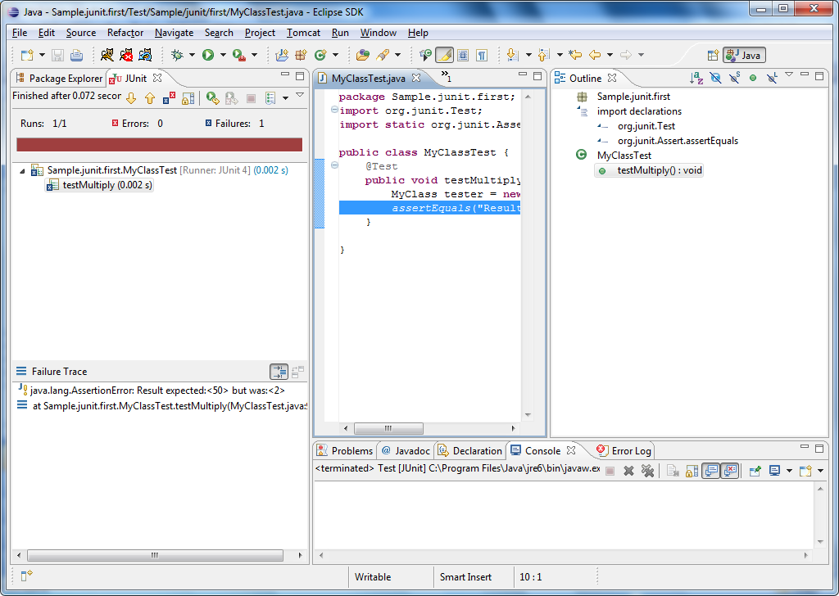
The test should be failing (indicated via a red bar). This is due to the fact that our multiplier class is currently not working correctly (it does a division instead of multiplication). Fix the bug and re-run test to get a green light.

Create a test suite
If you have several tests you can combine them into a test suite. All test in this test suite will then be executed.
Select your test classes , right mouse click-> New-> Other -> JUnit -Test Suite
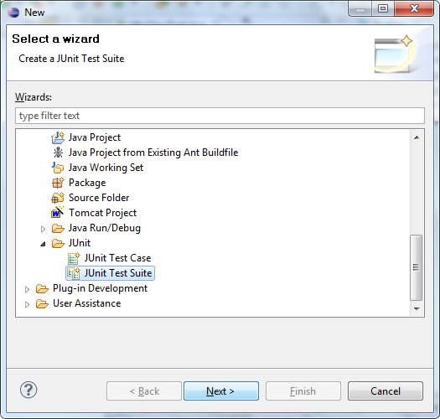
Select next and select the methods you would like to have test created for.
Press finish.
Change the coding to the following to make your test suite run your test. If you later develop another test you can add it to @Suite.SuiteClasses

package mypackage;

import org.junit.runner.RunWith;
import org.junit.runners.Suite;

@RunWith(Suite.class)
@Suite.SuiteClasses( { MyClassTest.class })
public class AllTests {
}

JUnit (more) in Detail

Static imports with Eclipse
JUnit uses a lot of static methods and Eclipse cannot automatically import static imports. You can make the JUnit test methods available via the content assists.
Open the Preferences via Window -> Preferences and select Java > Editor > Content Assist > Favorites. Add then via "New Member" the methods you need. For example this makes the assertTrue, assertFalse and assertEquals method available.
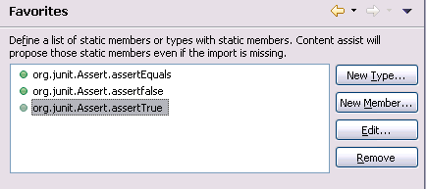
You can now use Content Assist (Ctrl+Space) to add the method and the import.
I suggest to add at least the following new members.
- org.junit.Assert.assertTrue
- org.junit.Assert.assertFalse
- org.junit.Assert.assertEquals
- org.junit.Assert.fail

Annotations
The following give an overview of the available annotations in JUnit 4.x

Table 1. Annotations
Annotation | Description
@Test public void method() | Annotation @Test identifies that this method is a test method.
@Before public void method() | Will perform the method() before each test. This method can prepare the test environment, e.g. read input data, initialize the class)
@After public void method() | Test method must start with test
@BeforeClass public void method() | Will perform the method before the start of all tests. This can be used to perform time intensive activities for example be used to connect to a database
@AfterClass public void method() | Will perform the method after all tests have finished. This can be used to perform clean-up activities for example be used to disconnect to a database
@Ignore | Will ignore the test method, e.g. useful if the underlying code has been changed and the test has not yet been adapted or if the runtime of this test is just to long to be included.
@Test(expected=IllegalArgumentException.class) | Tests if the method throws the named exception
@Test(timeout=100) | Fails if the method takes longer then 100 milliseconds

Assert statements
The following gives an overview of the available test methods:

Table 2. Test methods
Statement | Description
fail(String) | Let the method fail, might be usable to check that a certain part of the code is not reached.
assertTrue(true); | True
assertsEquals([String message], expected, actual) | Test if the values are the same. Note: for arrays the reference is checked not the content of the arrays
assertsEquals([String message], expected, actual, tolerance) | Usage for float and double; the tolerance are the number of decimals which must be the same
assertNull([message], object) | Checks if the object is null
assertNotNull([message], object) | Check if the object is not null
assertSame([String], expected, actual) | Check if both variables refer to the same object
assertNotSame([String], expected, actual) | Check that both variables refer not to the same object
assertTrue([message], boolean condition) | Check if the boolean condition is true.
try {a.shouldThroughException(); fail("Failed")} catch (RuntimeException e) {asserttrue(true);} | Alternative way for checking for exceptions

